合肥市初三上学期英语期末测试
英语试卷
学校 班级 姓名 分数

温馨提示：1. 全卷满分为100分，练习时间90分钟。
2.本卷共 6页，答案请做在答题卷上。
3.部分词汇可在后面的 “小字典”里查阅。
题号 | 一 | 二 | 三 | 四 | 五 | 六
得分
听力部分
一. 听力（共20分，每小题1分）------省略
笔试部分
二. 选择题（共10小题，每小题1分，计10分）
( ) 21.There’s “h” and “u” in the word “umbrella”
A. a , an B. a, a C. the, the D. an, a
( ) 22.—Could you tell me ?
—Yes, it is in Anji.
A. where is Mount Longwang B.where was Mount Longwang
B. where Mount Longwang is D.where Mount Longwang was
( ) 23.—What do you know about Yao Ming?
— Well, he since 2002.
- has been a member of the NBA B. has joined the NBA
C. joined the NBA D. had been a member of the NBA
( ) 24.When I was a child, my parenrs often asked out alone at night.
A. to go B. went C. not to go D. to not go
( ) 25.— the population of China, do you know?
- It’s more than 1.3 billion. It’s the largest country in the world.
A. What’s B.What are C.How many are D. How many is
( ) 26.I don’t know if my girlfriend tomorrow. If she , I will teach her how to search the Internet.
A. comes, will come B. will come, comes
C. will come, will come D. comes, comes
( ) 27.When you’re doing your homework, the more careful you are, th
mistakes you’ll make.
A. more B. better C. fewer D. less
( ) 28.Bamboo Anji. Do you know some chairs bamboo.
A. is grown in , are made from B. is grown, are made of
C. is growed in , are made into D. is grown in, are made of
( ) 29.We often hear Mary the song “ A Rat Likes Rice ”. Just now she was heard this song again.
A. sing, to sing B. to sing , sing
C. singing, sinmg D. to sing, to sing
( ) 30.——Happy New Year to you !
—— !
A. Thank you B. You are welcome
C. With pleasure D. The same to you
三. 完行填空 (共15小题, 每小题1 分, 计15分)
阅读下面短文,掌握其大意, 然后从下列各题所选的四个选项中选出一个最佳答案。
Miss Carter is a beautiful girl. Her father 1 two years ago and her mother made a terrible mistake and 2 . They began to live a hard life. When she 3 middle school, she couldn't go on studying. Her uncle found a 4 for her. Mr. Baker, a rich shopkeeper, hired her. Her work was to clean the rooms and sweep the floors. She tried her 5 and worked hard. Mrs. Baker liked her and paid her 6 than the other servants.
It was Sunday, Mr Baker was reading and Mrs Baker was watching TV in the sitting room. The girl came in and said, “I’m 7 ,Mrs. Baker. I have to tell you I can’t work for you any longer.”
It 8 Mr. and Mrs. Baker. The woman asked, “What makes you say that? Aren’t
we 9 to you? ”
“Yes, you are, madam,” the girl said. “Have you found a piece of 10 work yet?” Mrs. Baker asked.
“No, I haven’t ”Miss Carter said. “ 11 I don’t think you trust me.”
“You are 12 , Miss Carter,” said Mr. Baker. “I always think you are a 13 girl. And I often leave any keys in my study.” “It was 14 that you often left the keys in your study,” said the girl. “But I could use none of then to 15 the safe.”
“Well,” said Mr. Baker. “You can go right now!”
31. A．died B．dieded C. dying D. dead
32. A．hurried off B.hurried to C. sent away D. was sent away
33. A．finished B. stopped C. end D. over
34. A．work B. works C. job D. jobs
35. A．better B．good C. best D. well
36. A．much B．more C. little D. less
37. A . sorry B．glad C. angry D. please
38. A．in surprise B. surprise C. surprised D. surprises
39. A．friendly B．friend C. rich D. cold
40. A．good B．better C. best D. well
41. A. But B. And C. Though D. What
42. A．wrong B．right C. foolish D. bright
43. A. bad B．good C. well D. happy
44. A．poor B. true C. bad D. well
45. break B. answer C. find D. Open
四. 阅读理解(本题共15题，每题1分，计30分)
(A)

New books this month
The Long Night  This is David Reilly’s first book. David became a writer after teaching English for several years.  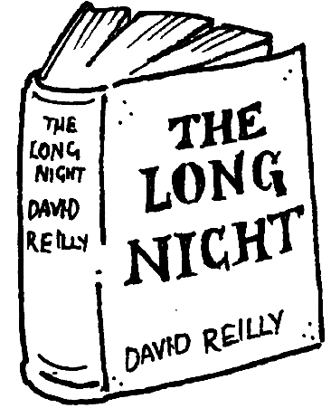  Maha is a nurse in northern Australia. She works in a small hospital. One day a baby is so ill that Maha has to drive all night to get her to the nearest big city. They have a lot of problems getting there and… | Hard Work  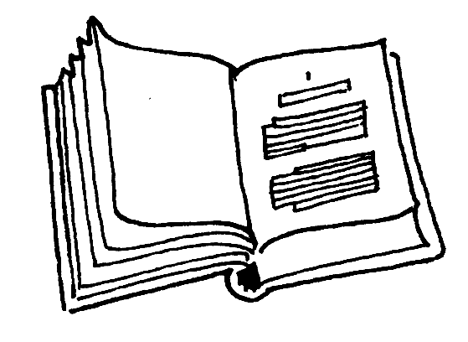  This exciting story is Joanna’s twentieth. Hard Work is about Sombat. He works with his father, a carpenter, in Thailand. They work long, hard hours making tables and chairs, but they do not have any money. Then one day a man dressed all in black buys the most beautiful table in the shop… | Hospital or Cinema  Marcie Jacome, who studies English in London, wrote this story earlier this year.  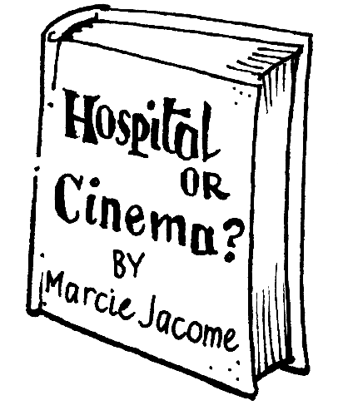  Tina is a young Indian woman whose dream is to become a doctor. She goes to London to study English and medicine, but one day she meets a man who asks her to go to the USA with him to become a film star…What will Tina do?
46 The Long Night was written by _________.
A. David Reilly B. Maha C. Joanna D. Marcie Jacome
47. The story of Hard Work happened in _________.
A. Australia B. Thailand C. India D. England
48. From the passage we can see Tina is ________.
A. a doctor B. a film star C. a writer D. a college student
49. __________is about a difficult journey.
A. Hospital or Cinema B. Hard Work C .The Long Night D. Harry Potter
50. The passage above is _________.
A. an ad B. a story C. a novel D. a diary
(B)
Some British and American people like to invite friends for a meal at home. You should not be upset if your English friends don't invite you home. It doesn't mean they don't like you!
Dinner parties usually start between 7 and 8 p.m. and end at about 11p.m.. Ask your hosts what time you should arrive. It's polite to bring flowers, chocolates or a bottle of wine as a gift.
Usually dinners start with drinks and snacks. Do you want to be extra polite? Say how much you like the room, or the pictures on the wall. But remember-it's not polite to ask how much things cost.
In many families, the husband sits at one end of the table and the wife sits at the other end. They eat with their guests.
You'll probably start the meal with soup or something small, then you'll have meat or fish with vegetables, and the dessert, followed by coffee. It's polite to finish everything on your plate and to take more if you want.
Did you enjoy the evening? Call your hosts the next day, or write them a short "thank you" letter. British and American people like to say "thank you, thank you, thank you" all the time.
51. How long does a dinner party usually last?
A. 7 or 8 hours. B. 11 hours. C. 3 or 4 hours. D. It is uncertain.
52. If you want to be a polite guest, you shouldn't_________.
A. ask how much the host's furniture cost B. bring some gifts to your host
C. say something nice about the host's room D. come at the right time
53. We learn from the passage that_________.
A. usually there are drinks at the beginning
B. the last course of the meal is usually soup
C. dessert is usually served before the main course
D. at the end of the meal ice cream is often served
54. What is not considered as right behavior?
A. To eat up everything on your plate. B. To ask for more if you really like it.
C. To leave some food to show you are not greedy.
D. To call your host the next day to express your thanks.
55. The guest will not bring__________ as a gift when he goes to a dinner party.
A. some nice flowers B. chocolates
C. a bottle of wine D. some money
(C)
Everyone is talking about bird flu. Yes, it is a very dangerous disease that could make many people very sick. It will be a few months still before we have good medicine for bird flu. But that does not mean you can do nothing to prevent it now.
So far, all the people who have caught bird flu have been those who touched sick chickens or their droppings. So it’s a good idea for people to stay away from live chickens. “people used to buy live chickens to eat , but now they have to change that habit ,”said Pewter Cordingley, a WTO expert. But if you do touched an ill bird, remember to wash your hands carefully with soup right away.
Experts also say having good habits and a healthy body will help keep you safe from bird flu. For example, do not buy or eat birds that have not been checked.
56.From the passage we can learn that ______.
A. if you touch any chicken ,you may catch bird flu.
B. it’s hard to stop people from staying with sick chicken
C. experts are trying to find good medicine for bird flu
D. people can do nothing to prevent bird flu.
57.Which of the following is not mentioned that can keep us from disease?
A..to stay away from live chick.
B. Do not have any vegetables and fruit.
C. Having good habits and a healthy body.
D. Do not eat birds that have not been checked.
58.It seems that bird flu is_______.
A. terrible and can never be cured.
B. Terrible but can be cured very quickly and easily
C.A special illness but nobody has died of the disease
D. Nothing too serious if we do the things in the right way.
59.What’s the best idea to prevent bird flu?
A. Stay away from live chicken. B. Wash our hands.
C. See a doctor D. Have good medicine.
60.What’s the title that best describes the passage?
A. Bird flu is really dangerous.
B. It’s an easy job to deal with bird flu.
C. Remember the Dos and Don’ts for preventing bird flu.
D. All the people are afraid of bird flu.
五. 任务型阅读(共5小题, 每小题1分，计5分)
阅读下面五则广告，以下五个人会对哪则广告感兴趣？请在广告下面写下他们的名字。
A．Michael wants a bike to ride to school .
B．Sandy owns some nice old photos of some famous film stars .
C．Maria is looking for a job . She has worked for 5 years in an office in New York .
D．Jack needs some money to buy himself some nice clothes .
E．Martin is going to college in another city ,so he needs a car to drive

1.Help Wanted :Babysitter for a 5-year-old boy ,3-5 p.m. from Monday to Friday.Call Mrs Adams,979-0765
2..Help Wanted :Secretary (秘书) with good computer skills in a company. Call Ted James ,667-1234

.

61 62

3 .Wanted to buy :Photos of Audrey Hepburn .
Will pay ＄＄
Call Alice ,834-1254
4.ForSale Red mountain bike ,almost new ,＄ 80.
Call Mary 898-0765
5.For Sale :1999 Toyota white ,two-door ,radio ,CD player .
Call Terry 886-6219

63 64 65
六. 写作(共20分)
假设你叫李平，暑假快到了，给你在美国的朋友汤姆写封e-mail，邀请他来中国旅游。在信中简单地向他介绍中国。内容包括以下要点，不少于60字。
要点：1.中国是世界大国之一，有悠久的历史；
2.中国有12亿人口，中国人民勤劳友好；
3.中国拥有许多大江、高山和举世闻名的长城；
4.2008年，奥运会（the Olympic Games ）将在中国举行，那时的中国将更加美丽、富强。
Dear Tom ,
How time flies ! Summer holidays will start , I hope

要求：1. 语句通顺，行文连贯，书写整洁。
2. 字数不少于60字。
3. 可适当展开合理想象。
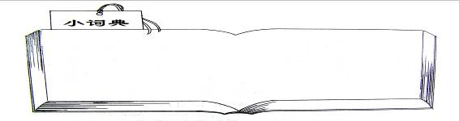
president(总统)upset (不高兴)dessert(甜点)remarried(再婚)snacks(快餐).bird flu(禽流感)greedy（贪心）extra (额外的)expert（专家）

初三上学期英语期末测试
英语试卷

参考答案
- 听力题。--------省略

- 单项选择
21–25 DBACA 26–30 BCDAD

- 完形填空
31–35 ADACC 36–40 BACAB 41–45 AABBD

- 阅读理解
46–50 ABACA 51–55 CDACD 56–60 CBDAC
- 任务型阅读
61–65 DCBAE

- 写作---------省略
Dear Tom ,
How time flies! Summer holidays will start .I hope you can come to China, China is one of the biggest countries in the world .It has a long history and there are about 1200 million people .The Chinese people are a hard – working people and we are very friendly. She has a lot of high mountains and long rivers and she is famous for the Great Wall. The Olympic Games will be hold in China in 2008. By then, China will be more beautiful and richer.
Welcome to China!
Yours,

评分档次：
1．第一档 (18—20分) 信息完整，表达流畅，无语言错误或基本无语言错误。
2．第二档 (15—18分) 信息基本完整，表达较流畅，有少量错误，但不影响意思表达
3．第三档（10—15分）能传递部分信息，表达不够流畅，语言错误较多，但句子基本可读。
4．第四档 (6—10分)）只能传递少量信息，表达不通顺，语言错误多，只有少量句子可读。
5．第五档（1—6分） 基本无法获取相关信息，

山川中学 吴礼新

